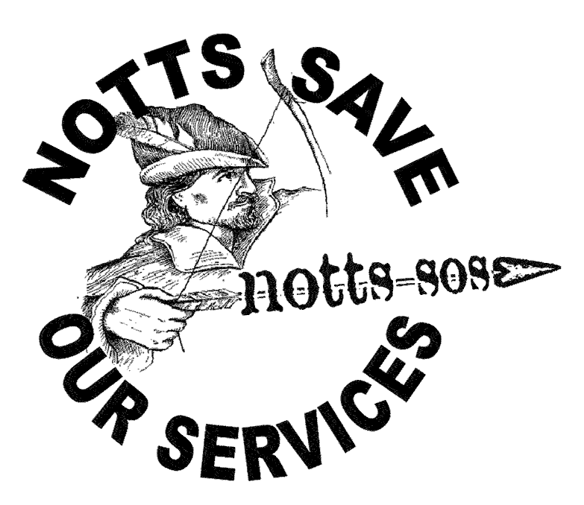
NOTTS SOS
Newsletter Nº3 ◊◊◊ February 2011
Defending jobs, services, welfare & education against cuts in Nottingham and Nottinghamshire

Voices for the library
Save Sherwood Forest
More than 70 people from across the county packed into a public meeting convened by Notts Save Our Services and the Climate Alliance to oppose government plans to sell off forests, including Sherwood Forest.
They were clear that the ownership of Sherwood Forest, which has a global identity as part of the legends of Robin Hood, matters. It is something that is too vital and deeply rooted in the people of Nottinghamshire to be simply sold off by the government.
A large part of the forest is held and operated by the Forestry Commission behalf of the people.
We cannot allow our forest to be sold in response to the ravages of the banking crisis. Sherwood Forest is at the core of our heritage, a wonderful amenity for all and an essential part of who we are now and also of our common future.
The Save Sherwood Forest Campaign is about to launch and is organising a mass event in the forest in the Spring to fight the sell off.

www.savesherwoodforest.org.uk
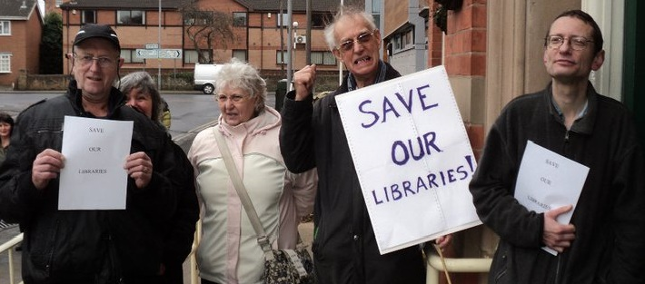

Hundreds of people across the county joined “Read-Ins” in local libraries, including Beeston, Chilwell, Stapleford, Sneinton, Toton and Carlton as part of a national day of protest against library closures on Saturday 5 February.

Beeston and Chilwell Defend Library Services organised the event at Beeston Library to protest against Conservative-run Nottinghamshire County Council’s proposals to cut Beeston Library’s opening hours from 57 hours a week to 52. Under the proposals, opening hours at Inham Nook Library in Chilwell would also be cut from 20 hours to just eight.
Public opposition to the plans has been escalating. In January more than 500 people signed a petition against the cuts during just two hours of leafleting in Beeston town centre and more than 100 people attended a public meeting organised by the campaign group at College House Junior School. It will also be lobbying County Councillors at county Hall, West Bridgford on the 24th February.

Sneinton Against The Cuts organised The Great Sneinton Library Read In. The group condemned Nottingham City Council’s decision to start charging for using library computers. It has also organised a petition against the introduction of these charges and has put together a complaints letter template. It says that there was no consultation and no notice was given of the introduction of charges. voicesforthelibrary.org.uk
NOTTS SAVE OUR SERVICES – February 2011

Notts Uncut tells Vodaphone, Boots and Top Shop: Pay your taxes!
Dozens of Notts UK Uncut protestors closed Vodafone, Boots and Arcadia shops across Nottingham as part of the latest national protests on 30 January. Students joined trade unionists from PCS, Unison, CWU, RMT and the NUT to serve Vodaphone with a £6 billion tax bill before marching to Boots in Victoria Centre.

Boots is a Nottingham based company; but since a private equity buyout in 2008, its HQ
has moved to Switzerland. The amount of tax it paid has fallen from £131 million to less than £20 million, while hundreds of workers have lost their jobs at the firm. The protestors also held a rally in Top Shop in protest at the actions of multi-billionaire businessman Phillip Green, who owns brands including Topshop and Topman.

UK Uncut says: “In 2005 Philip Green awarded himself £1.2bn, the biggest paycheck in British corporate history. But this dividend payout was channeled through a network of offshore accounts, via tax havens in Jersey and eventually to Green’s wife’s Monaco bank account. The dodge saved Green, and cost the tax payer, close to £300m.”
Avoiding tax is big business. British corporations avoid up to £25 billion a year in tax – money that could be used to invest in services and protect jobs.


- UK Uncut also called on the company to stop supporting dictators after the Financial Times newspaper reported that it transmitted pro-government text messages and “Some texts on Vodafone’s network appeared to urge Mr Mubarak’s supporters to confront the anti-government protesters” in Egypt.
GET INVOLVED – What can we do?
Some of the many anti-cuts activities and Notts SOS meetings this month. More on the web.
Tuesday 22th February - Nottingham City Unison public demonstration with speakers. 12.30-1.30pm in the Market Square, Nottingham in front of the Council House. This is the day that the City Council Executive Board discusses and recommends the 2011/12 budget to the full council. All welcome.
Thursday 24th Feb – Major lobby of Nottinghamshire County Council at County Hall, West Bridgford. Assemble at the Embankment war memorial at 10.00am for an 11.00am start of a march to County Hall across Trent Bridge to lobby until 1.00pm, on the day the full council meets to set its Council Tax budget.
Monday 28st Feb - Notts SOS planning meeting from 7.30-9.15pm. ICC/YMCA, 61b Mansfield Road.
Saturday 5th March Notts SOS rally in Market Square against the City Council budget. 12 noon start. All welcome. Bring banners, placards & things to make noise including yourself!
Monday 7th March – Demonstration in the Market Square starting at 1.00 pm when the City Council’s budget for 2011/12 will be considered at a meeting of the full City Council to be held at the Council House, Old Market Square, Nottingham (Council meeting starts 2.00pm).
Also in February - Save Post Offices (19th), Mencap Big Cuts (23th), Woodland Walk (24th). More in March.
March 26th: TUC ‘March for the alternative’ http://marchforthealternative.org.uk/. Put this in your diary!
Tell your workmates, friends and neighbours about our campaign and get involved in saving our services.
CONTACT US Phone: 07940 952 825 Email: nottssos @ gmail.com Web: http://nottssos.org.uk

